tan in 
self_driving_car_nanodegree_program 
tan out 
ime Step: 499 
RMSE 
Y:0D197 
vx:s.199 
vy:omoo 
Dataset 1 
Dataset 2 
Start 

Noticed that R\_ value was not initialized. Initialized it according to the sensor.

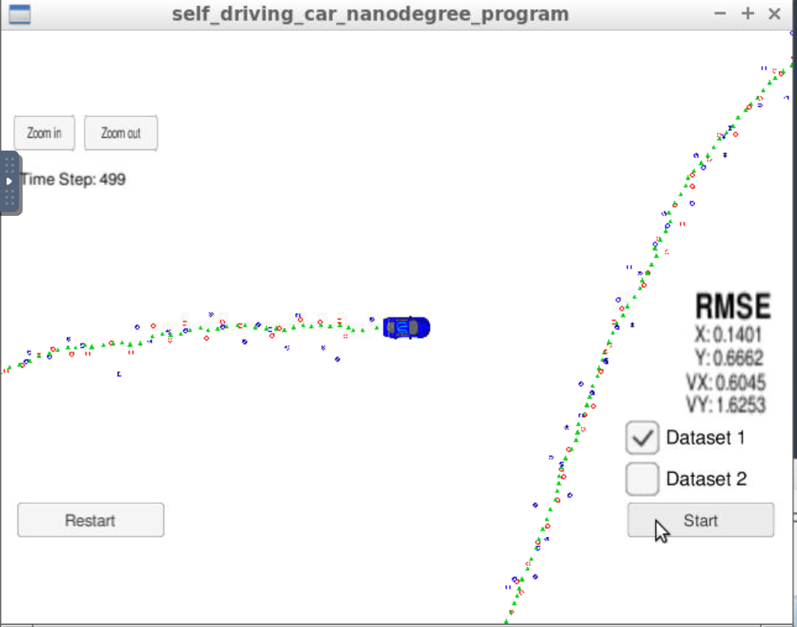

After moving jacobian calculation to EKF and also updating H\_ matrix for lasers

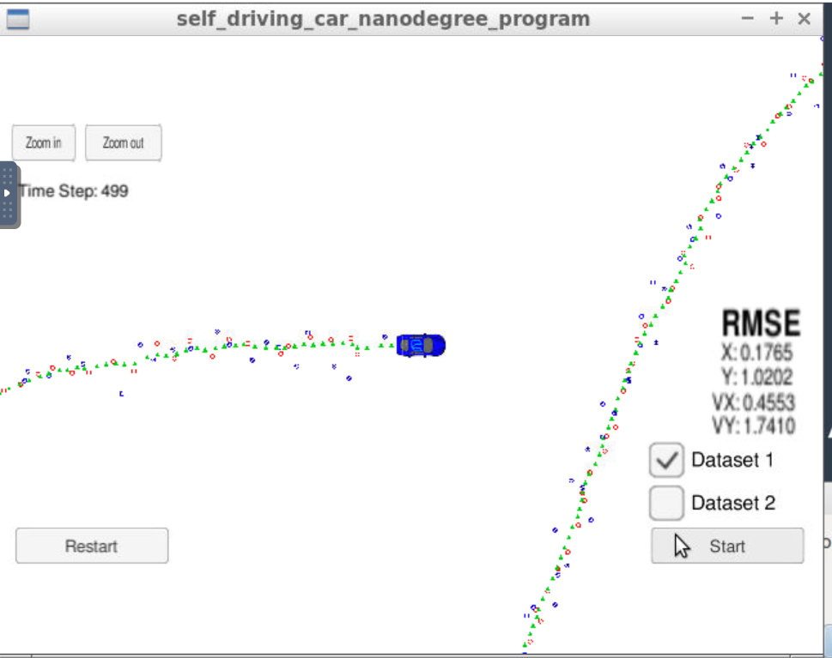

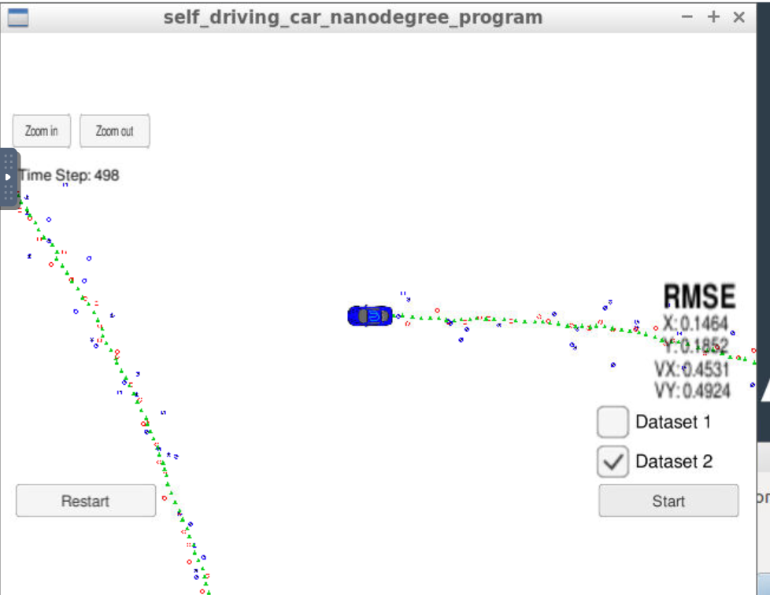

After changing all to doubles

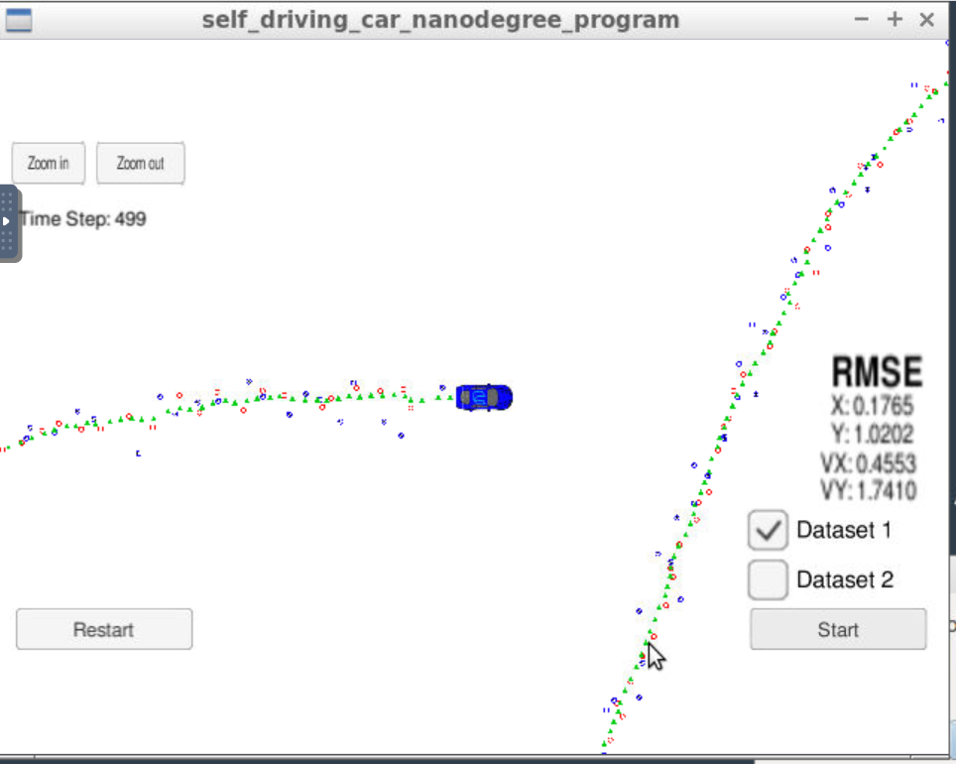

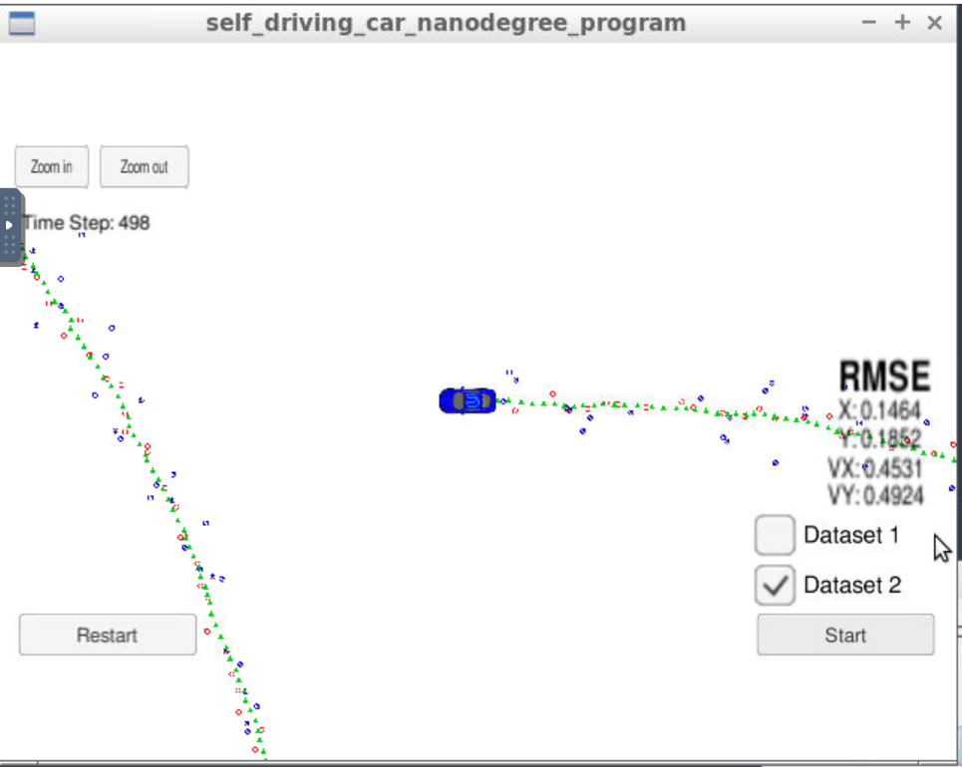

Normalizing angles

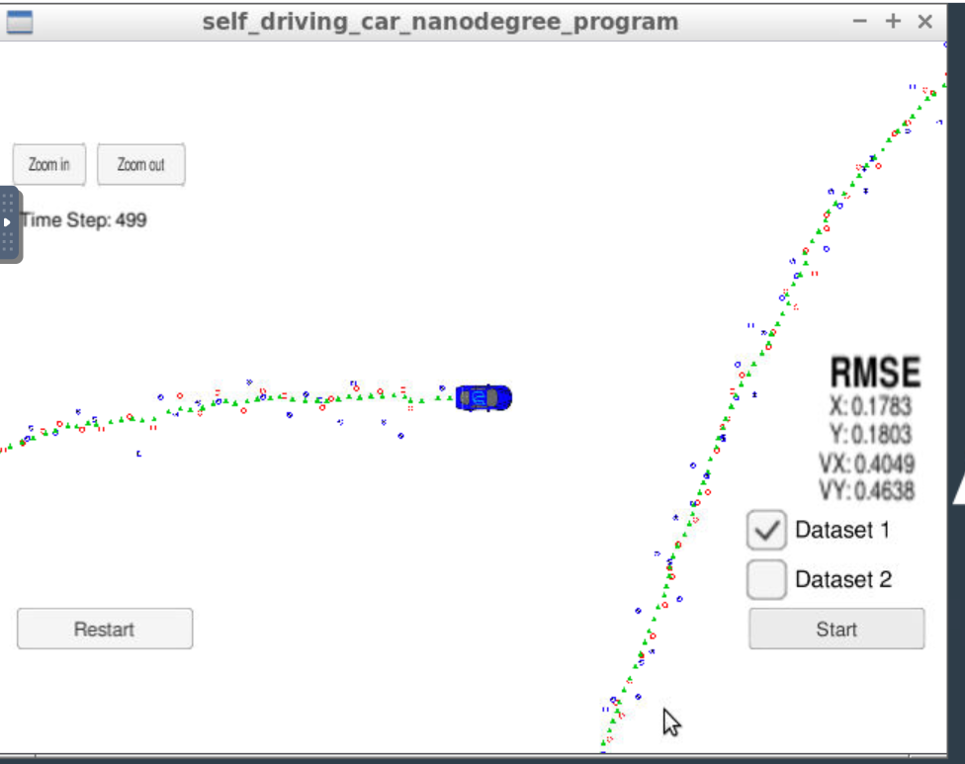

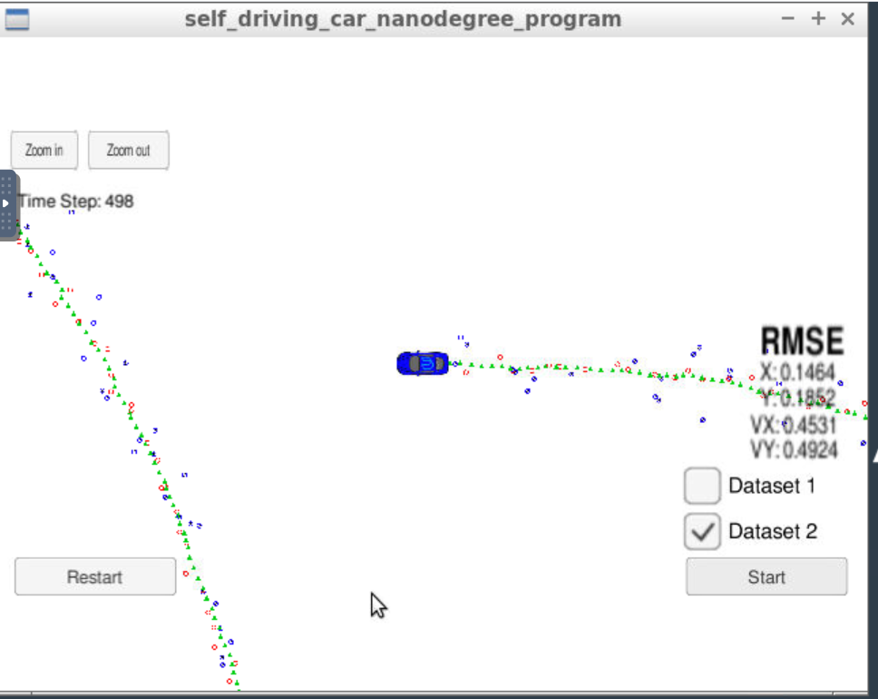

Removed the H matrix dt update. Not needed. Pi value change did the most.

